Camilo Andrés Quintero Rodríguez

Grupo 6

1. Sección 2.1: 1, 3, 4(a, d, j, k, m), 5, 8, 9, 13, 14





$${H como una funcion de n parámetros H: B}^{n}→B$$

$$H: B^{1}→B$$

$$H\left(F\right)=F$$

$$H\left(V\right)=V$$

|  |  |  |  |  |  |
| --- | --- | --- | --- | --- | --- |
| p | q | $$(p≡q)$$ | $$(¬(p≡q))$$ | $$(p≢q)$$ | $$((¬(p≡q))≡(p≢q))$$ |
| F | F | T | F | F | **T** |
| F | T | F | T | T | **T** |
| T | F | F | T | T | **T** |
| T | T | T | F | F | **T** |





|  |  |  |
| --- | --- | --- |
| True | False | $$(true≢false)$$ |
| T | F | T |



|  |  |  |  |
| --- | --- | --- | --- |
| p | q | $$(¬q)$$ | $$(p∧(¬q))$$ |
| F | F | T | F |
| F | T | F | F |
| T | F | T | T |
| T | T | F | F |



|  |  |  |  |
| --- | --- | --- | --- |
| p | q | $$(p∧q)$$ | $$((p∧q)→p)$$ |
| F | F | F | T |
| F | T | F | T |
| T | F | F | T |
| T | T | T | T |



|  |  |  |  |
| --- | --- | --- | --- |
| p | q | $$(p∨q)$$ | $$(p→(p∨q))$$ |
| F | F | F | T |
| F | T | T | T |
| T | F | T | T |
| T | T | T | T |



|  |  |  |  |  |  |  |
| --- | --- | --- | --- | --- | --- | --- |
| p | Q | r | $$\left(q≡r\right)$$ | $$\left(p≡\left(q≡r\right)\right)$$ | $$\left(p≡q\right)$$ | $$\left(\left(p≡q\right)≡r\right)$$ |
| F | F | F | T | F | T | F |
| F | F | T | F | T | T | T |
| F | T | F | F | T | F | T |
| F | T | T | T | F | F | F |
| T | F | F | T | T | F | T |
| T | F | T | F | F | F | F |
| T | T | F | F | F | T | F |
| T | T | T | T | T | T | T |

|  |
| --- |
|  |
| T |
| T |
| T |
| T |
| T |
| T |
| T |
| T |



|  |  |  |
| --- | --- | --- |
| p | q | $$(p∧q)$$ |
| F | F | F |
| F | T | F |
| T | F | F |
| T | T | T |

|  |  |  |  |  |
| --- | --- | --- | --- | --- |
| p | q | $$(p∨q)$$ | $$(p≡q)$$ | $$((p∨q)≡(p≡q))$$ |
| F | F | F | T | F |
| F | T | T | F | F |
| T | F | T | F | F |
| T | T | T | T | T |

|  |  |  |
| --- | --- | --- |
|  |  | **)** |
| F | F | **T** |
| F | F | **T** |
| F | F | **T** |
| T | T | **T** |

$φ:(((p∨q)≡(p≡q))≡(p∧q)$)

$$H_{φ}\left(F,F\right)=H_{φ}\left(F,F\right)=H_{φ}\left(F,F\right)= H_{φ}\left(T,T\right)=T$$

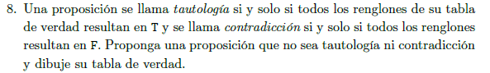

|  |  |  |  |
| --- | --- | --- | --- |
| p | q | $$(¬q)$$ | $$(p∧(¬q))$$ |
| F | F | T | F |
| F | T | F | F |
| T | F | T | F |
| T | T | F | F |

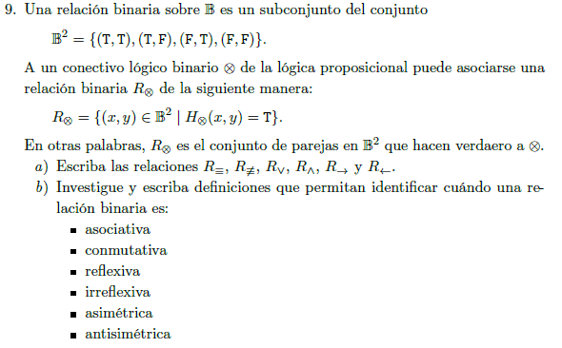

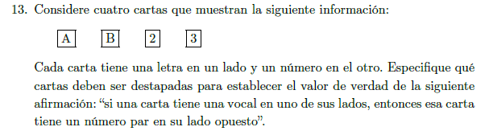

|  |  |  |
| --- | --- | --- |
| p | q |  |
| F | F | T |
| F | T | T |
| T | F | F |
| T | T | T |

$$M_{→}\left(F,F\right)=M_{→}\left(F,T\right)=M_{→}\left(T,F\right){=M}_{→}\left(T,T\right)=T$$

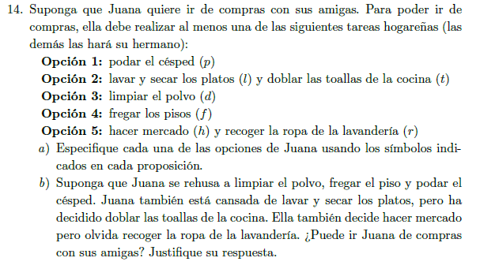



$$p:Juana poda el césped$$

$$l:Juana lava y seca los plats$$

$$t:Juana dobla las toallas de la cocina$$

$$d:Juana limpia el polvo$$

$$f: Juana frega los pisos$$

$$h: Juana hace mercado$$

$$r:Juana recoge la ropa de la lavandería$$

$$q:Juan sale de compras con sus amigas$$

$$Opción 1:p$$

$$Opción 2: (l∧t)$$

$$Opción 3:d$$

$$Opción 4:f$$

$$Opción 5: (h∧r)$$

$$(p∨\left(l∧t\right)∨d∨f∨\left(h∧r\right))→q)$$

|  |  |  |  |  |  |  |  |  |  |  |  |
| --- | --- | --- | --- | --- | --- | --- | --- | --- | --- | --- | --- |
| $$p$$ | $$l$$ | $$t$$ | $$d$$ | $$f$$ | $$h$$ | $$r$$ | $$p$$ | $$(l∧t)$$ | $$d$$ | $$f$$ | $$(h∧r)$$ |
| F | F | T | F | F | T | F | **F** | **F** | **F** | **F** | **F** |

$$φ:p$$

$$∂: (l∧t)$$

$$δ:d$$

$$ω:f$$

$$τ: (h∧r)$$

$$H_{φ}\left(F\right)=H_{∂}\left(F,T\right)=H_{δ}\left(F\right)=H_{ω}\left(F\right)=H_{τ}\left(T,F\right)=F$$

1. **Sección 2.2: 1, 6, 7, 8, 9.**

